IMC 446
Week 3 Assignment
Read this Canadian Club Case Study and answer the questions that follow.
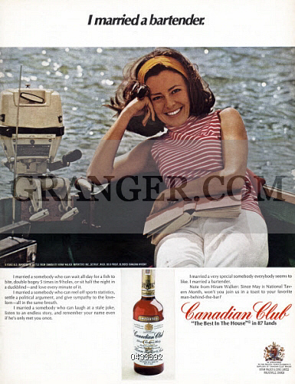
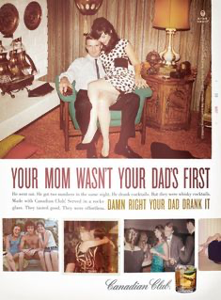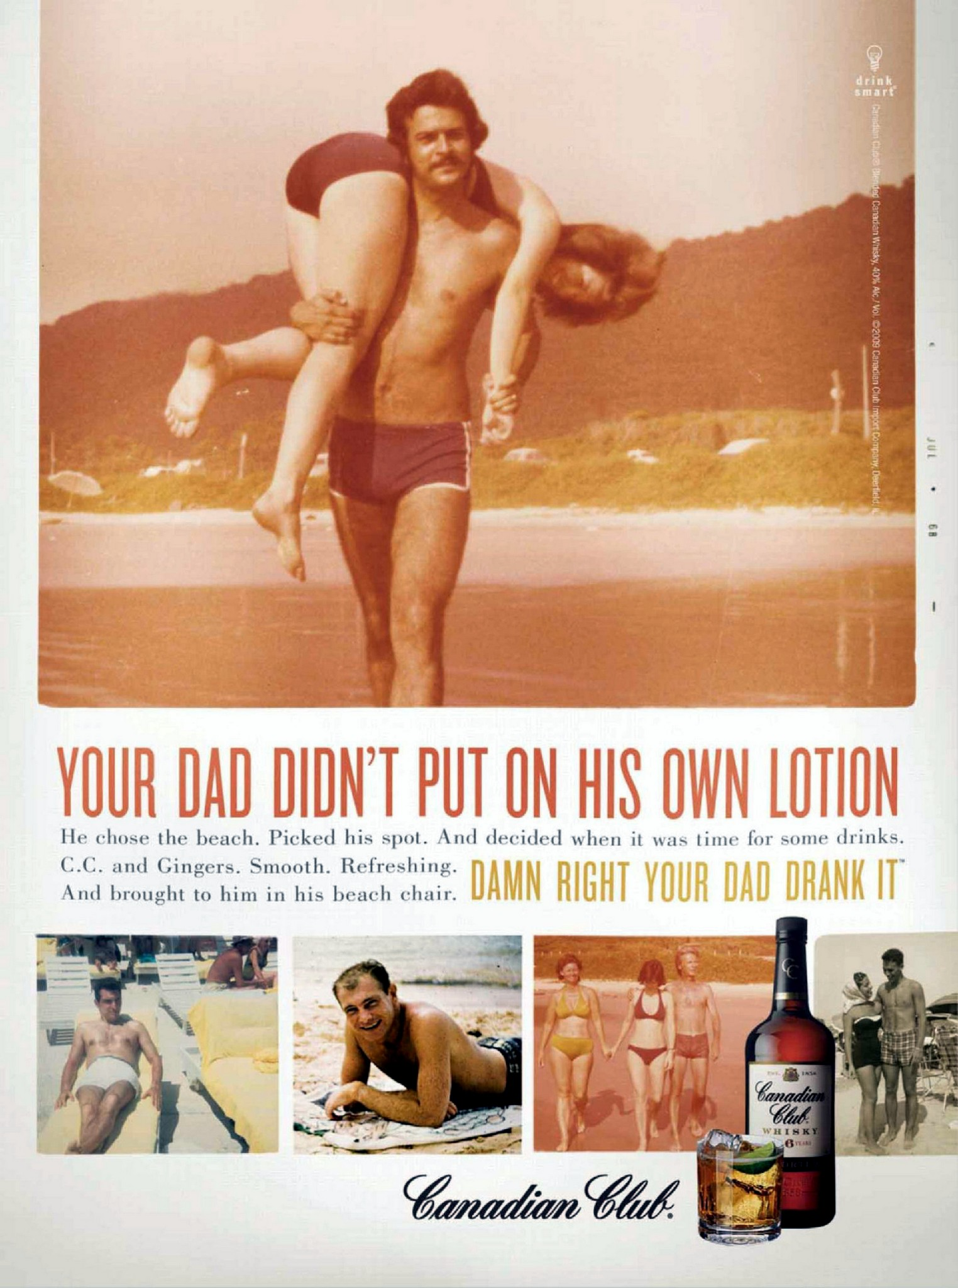

Case Study: Canadian Club Campaign.
As a well-established whisky brand, Canadian Club Whisky was struggling to engage a new generation of consumers. Once a celebrated brand back in the 60s and 70s, Canadian was sliding down the sales rankings from its regular top 10 placement to a lowly 36th in 2007.
Market research and anecdotal evidence showed that while many of the target drinkers (aged 30-39) were aware of the brand, it was only for its historical value as something drunk by their parents.
A campaign was needed that would reposition the brand in the growing spirits market, stem the decline in sales, and improve the Canadian Club's bar presence.
Agency: The overall goal was to stop a steady 16-year sales decline, which was achieved in the first month of the campaign launch.
New Direction: The creative brief was to “put the masculinity back into cocktails.” Canadian Club wanted to target a younger core audience, guys in their 30s, and these guys didn’t really have a go-to drink that tasted good, and they felt manly holding.
Research: They went out and talked to people in bars, interviewed bartenders—because if anyone would know, they would. And discovered that no one knew what Canadian Club was.”
In the Sex and the City era of female-centered, clear liquor cosmos all the rage, the agency racked their brains: How do we get guys to drink cocktails? And the idea emerged. Through preliminary research, the creative discovered that young men weren’t drinking brown spirits because, essentially, they were thought of as “dad drinks.”
Question 1:
Where would Canadian Club fall on Maslow’s Hierarchy? Name the level only.
Belongingness and Love.
Question 2:
Identify the emotional benefit of Canadian Club?
Feeling manly.
Question 3:
What did the creatives discover through primary research that was the insight for the campaign?
Young men weren’t drinking brown spirits because, they were thought of as “dad drinks.”
Question 4:
What was the positioning of Canadian Club for the campaign? List
Reclaiming the “manly” drink status.
Question 5:
Two-part question:
What would be the target demographics - sex and age range? List
- Gender: Men
- Age Range: 30-39
Name two psychographic characteristics of the target? List
- Valuing traits like confidence and masculinity.
- Looking for social acceptance from friends.

Extra Credit – 5 pts. What type of decision-making was Canadian Club for the target?
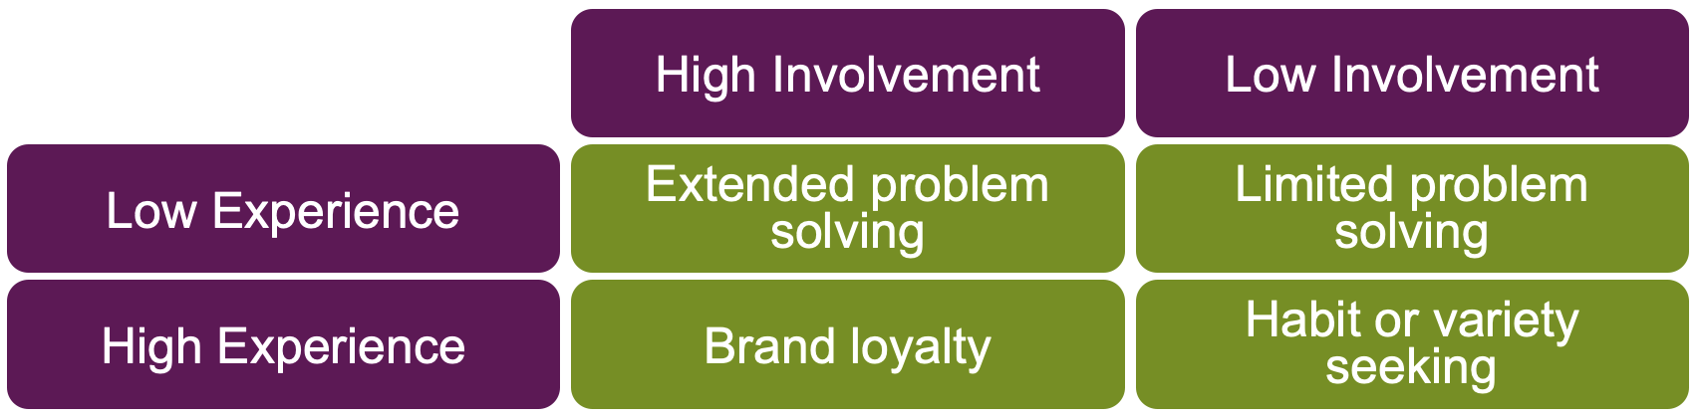

Limited Problem Solving.

